A
SEMINAR REPORT
ON

Age and Gender Detection

Submitted by

Abhishek Gidveer
Vyankatesh Yemul
Sayesh Ankaram

Under the guidance of

Mr. P.A. Kamble


ELECTRONICS AND TELECOMMUNICATION ENGINEERING

WALCHAND INSTITUTE OF TECHNOLOGY,
SOLAPUR
2021-22

Introduction

The human face may provide a wealth of information about personal traits such as identification, emotional expression, gender, age, and so on. Aging has a significant impact on the appearance of the face. This has a tremendous impact on human nonverbal communication. Age and gender, two important facial characteristics, play a critical role in social interactions, making age and gender estimation from a single face image a critical task in machine learning applications such as access control, human-computer interaction, law enforcement, marketing intelligence, and visual surveillance.

Automatic gender classification and age recognition could be a crucial task in computer vision, which has received a lot of attention recently. It is used in a wide range of real-world applications, including targeted advertising, forensic science, visual surveillance, content-based searching, human-computer interface systems, and so on. For example, we can use this strategy to display advertisements that cater to different genders and age groups. This strategy could be used in a variety of mobile applications that include age-restricted content so that only the proper users can see it.

There are numerous works proposed for age and gender prediction in the past several years. The earlier works were mainly based on hand-crafted features extracted facial images followed by a classifier. But with the great success of deep learning models in various computer vision problems in the past decade, the more recent works on age and gender predictions are mostly shifted toward deep neural networks-based models.

The main purpose of this project is to obtain values related to Age and Gender of a subject, by detecting subject’s face & converting colored pixels into b/w pixels. These b/w pixels are later compared with the initial pixel values present in Open-Source Data set thus resulting in precise Age group and Gender type of a subject.

This project can further be modified using high accuracy Machine Learning algorithms and frameworks making it even more significant and relevant in the fields of Real-World applications such as social understanding, biometrics, identity verification, video surveillance, human-computer interaction, electronic customer, crowd behavior analysis, on- line advertisement, item recommendation, and many more.

LITERATURE SURVEY

Gender recognition has found its strong applications in fields of authentication, search engine accuracy, demographic data collection, human computer interaction, access control and surveillance, involving frontal facial images. It can also be used as indexing technique to reduce the search space for automatic face recognition.

Human face may be a storehouse of various information about personal characteristics, including identity, emotional expression, gender, age, etc. the looks of face is affected considerably by aging. This plays a significant role in nonverbal communication between humans. Age and gender, two key facial attributes, play a really foundational role in social interactions, making age and gender estimation from one face image a very important task in machine learning applications, like access control, human-computer interaction, law enforcement, marketing intelligence and visual surveillance.

Automatic gender classification and age detection may be a fundamental task in computer vision, which has recently attracted immense attention. It plays a very important role in an exceedingly wide selection of the real-world applications like targeted advertisement, forensic science, visual surveillance, content-based searching, human computer interaction systems, etc. for instance we are able to use this method to display advertisement supported different gender and different age bracket.
This method may be employed in different mobile applications where there's some age restricted content in order that only appropriate user can see this content. However, gender classification and age approximation are still a difficult task. We propose a model which can first perform feature extraction on the input image which can classify eyes, lips, beard, hair, etc. Supported these features the model will classify the gender as male or female.

FLOWCHART

Setting up Camera for Face Detection using OpenCV2

(OpenCV2 is an Open-Source Computer vision & ML Library used for computer visualizations)
Converting colored pixels (original image captured using camera) into b&w pixels using DNN Architecture
(DNN is a pre-trained deep neural network model which can be openly used with OpenCV2)

Converting b&w pixel values into multi-dimensional matrices

Implementing Initial Dataset models for face, age & gender along with their file paths in order to make them accessible within the program

Loading earlier Implemented models into the program for further processing

Comparing current Matrix values with Initial Dataset values using dnn

Finally obtaining result on the output side based on above characterization

Characterizing the result in a specific age group using the Mean values, Gender list & Age list

Methodology

As mentioned before, the Terminology of this project is solely based upon matrix values of RGB, Greyscale, B&W pixels which define outcome of this project along with the help of Open-Source dataset training models, universal Mean values, DNN architecture, OpenCV2 Library & Blob (Binary Large Object). However, based on the flowchart depicted above, the exact workflow of this project can further be elaborated through following steps:

Step 1: Initializing Camera for the subject’s Face Detection using OpenCV2 Library.
(OpenCV2 is an Open-Source computer vision and machine learning library used for computer visualizations).
Step 2: Capturing subject’s face using CV2.VideoCapture method.
Step 3: Transforming the colored pixels that are obtained from subject’s face into B&W pixels in order to make it easier to match with the B&W pixels that are present in the Training data set using DNN architecture.
(DNN is a pre trained Deep Neural Networking model).
Step 4: Converting B&W pixel values into Multi-Dimensional Matrices.
Step 5: Implementing Open – Source data set training models for face, age and gender along with their file paths and storing them inside specific variables.
Step 6: Reading contents from earlier implemented models using cv2.dnn.readNet() method.
Step 7: Comparing current matrix values with initial dataset values using DNN.
Step 8: Based on above comparison, characterizing the obtained results in a specific Age group and Gender type using the Universal Mean values, Age list and Gender list.
Step 9: Obtaining final result on the output side base on above characterization.

Hardware & Software Requirements

Hardware Requirements:

- RAM - 8 Gb or more

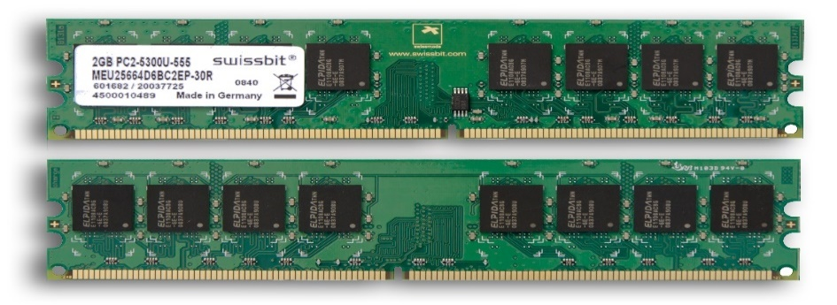

Random access memory (RAM) is your system’s short-term data storage; it stores the information your computer is actively using so that it can be accessed quickly. The more programs your system is running, the more memory you’ll need.

- CPU - Intel i3 series/AMD Ryzen series or newer

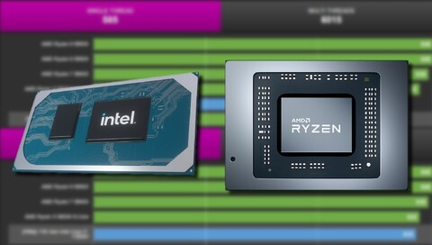

The CPU is the primary component of a computer that processes instructions. It runs the operating system and applications, constantly receiving input from the user or active software programs. It processes the data and produces output, which may be stored by an application or displayed on the screen.

- GPU - Nvidia GTX 700 series/AMD Radeon RX 500 series or newer



A graphics processing unit (GPU) is a computer chip that renders graphics and images by performing rapid mathematical calculations. GPUs are used for both professional and personal computing. Traditionally, GPUs are responsible for the rendering of 2D and 3D images, animations and video -- even though, now, they have a wider use range.

Software Requirements:

- Operating System - Windows 8/10/11
- Programming Language - Python 3.8 or newer
- IDE - PyCharm Community Edition
- Environment - PIP Virtual Environment 3.8 or newer
- Library - OpenCV2
- Models – DNN model, Open-Source Caffe Training dataset model with Universal Mean values

Advantages

- Helps in finding missing person.
- Improves medical treatment.
- Protects business against theft.
- Makes shopping more efficient.
- Improves photo organization.
- Prevents children from accessing adult sites.
- Prevents old aged people from experiencing VR tech.

Disadvantages

- Huge storage requirements.
- Vulnerable detection.
- Privacy issues.
- Camera quality.
- Less accurate results.
- Pixel complexity.

Applications

- Social understanding.
- Biometrics.
- Identity verification.
- Video surveillance.
- Human-computer interaction.
- Electronic customer
- Crowd behavior analysis.
- On- line advertisement.
- Item recommendation.

